Assignment 2 – Suim Park(1796138)

1. A software development company is changing from a traditional SDLC to Agile. Explain methodology, benefits and how can the developers adapt to this methodology.

* The traditional method uses a linear approach and it is based on a predictive approach.
* Agile methodology came from the idea that every project should be handled differently.
* Agile is based on the adaptive software development methods.
* Agile methodology takes iterative approach. The whole project is divided in small thing and they are provided with software build in each step. Each build is incremental in terms of features and the final build includes all the features required by the customer.
* It enables concurrent development and delivery within an overall planned context.
* A graphical illustration of the Agile methodology is as below.

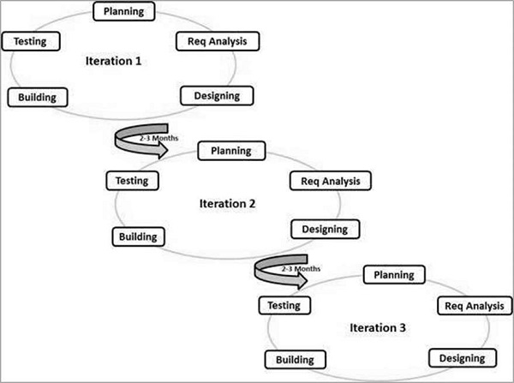

1. What is MVC and explain its architecture. How it works and benefits project? Find advantages and disadvantages. Include diagrams for your answer.

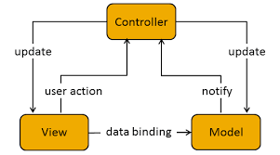

* The view is responsible for getting user action and defining and rendering the UI.
* The model manages the application data, and it is manipulated by getter and setter.
* The controller reacts to events coming from view. It controls user’s requirements between view and model and it modifies the view and model.
* MVC supports rapid and parallel development - If an MVC model is used for a web application then it is possible that one programmer can work on the view while another can work on the controller to create business logic.
* Modification does not affect the entire model – User interface could be changed frequently for example, colors, fonts, screen layouts etc. Model doesn’t depend on the view so that it is easy to add new type of views. Therefore, any changes in the Model will not affect the entire architecture.

1. What is JSP? What are the different tags in JSP? What are the benefits of using JSP in a project? Compare JSP vs HTML.

* JSP stands for Java Server Pages. It is a server-side programming technology that enables the creation of dynamic, platform-independent method for building Web-based applications.
* JSP Tags:
  + Declaration : <! Jsp declaration %>
  + Expression : <%= Java statement %>
  + Directive or message tags : <%@ dir-type-dir-attr %>
  + Scriptlet tags : <% Java code %>
  + Flow Control : if, for, foreach
  + Comment : <% / comments /%>
* Benefits of JSP
  + JSP enables generating dynamic page.
  + JSP is platform independent.

1. What is Maven? Add screenshots of step by step tutorial of creating a Maven Project in eclipse. Copy and paste pom.xml and explain its code.

* Maven is a build automation tool used primarily for Java projects.
* Steps of creating a Maven project in eclipse

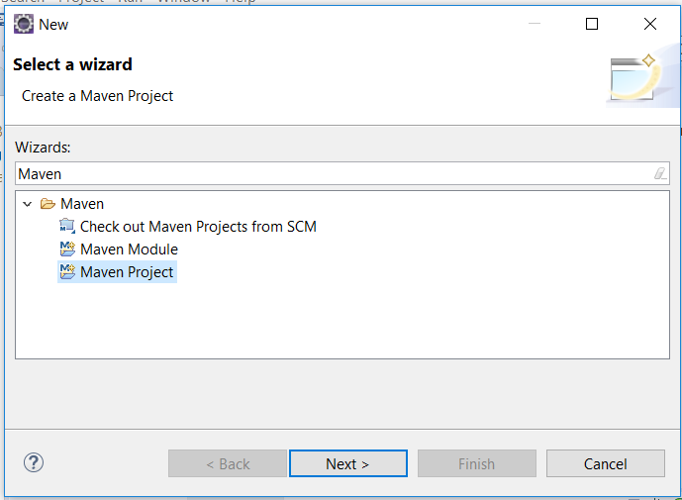

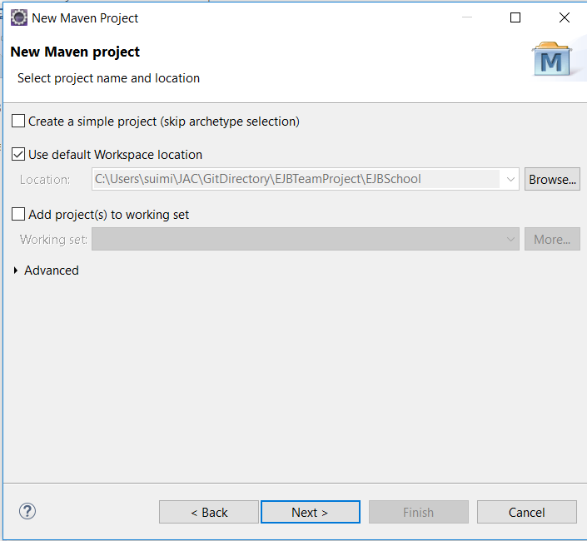

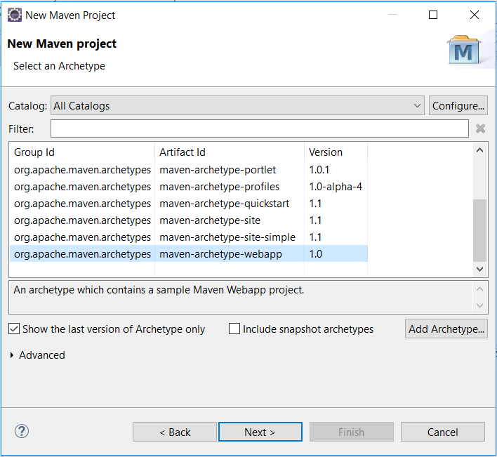

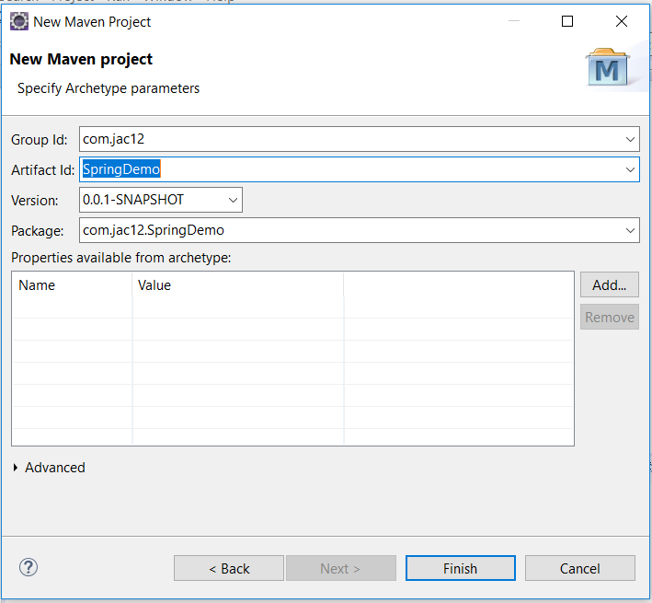

* Pom.xml

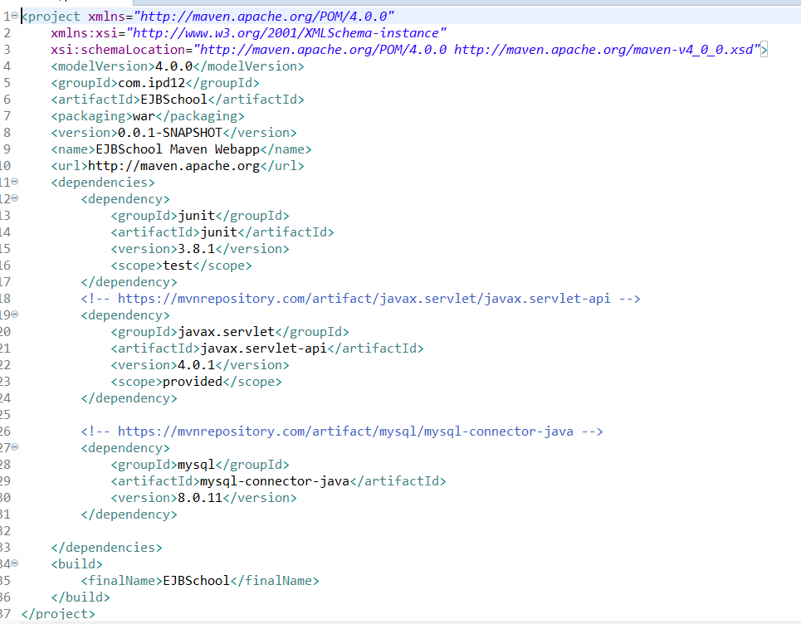

* + Framework add jar(library) automatically by copying dependency from mvcrepository.
  + From line number 19 to 24 is for java servlet.
  + From line number 27 to 31 is for mysql connector

1. What are the benefits of using Spring over J2EE applications? Also, find some benefits of having Hibernate in a project.

* Benefits of using Spring
  + Spring provides an abstraction layer on existing technologies like servlets, jsps, jdbc, jndi, rmi, jms and Java mail etc., to simplify the development process.
  + Spring WEB framework has a well-designed web MVC framework.
  + Spring can eliminate the creation of the singleton and factory classes.
  + Spring provides a light weight container which can be activated without using webserver or application server.
* Benefits of having Hibernate in a project
  + Hibernate ensures automatic connection between the application’s objects with the database tables. It prevents developers from writing lines of connection code.
  + It makes developers more concentrate on the business logic so that project’s productivity increase.
  + Hibernate is database independents. It can be used to connect with any database like Oracle, MySQL, Sybase and DB2. It is easily achieved by changing a parameter <database dialect> in the configuration file.
  + Hibernate supports HQL(Hibernate Query Language). HQL is more powerful than SQL and is completely object oriented.
  + It is free and open source so it is cost effective.
  + Hibernate is object oriented concept which means it is easy to learn.